**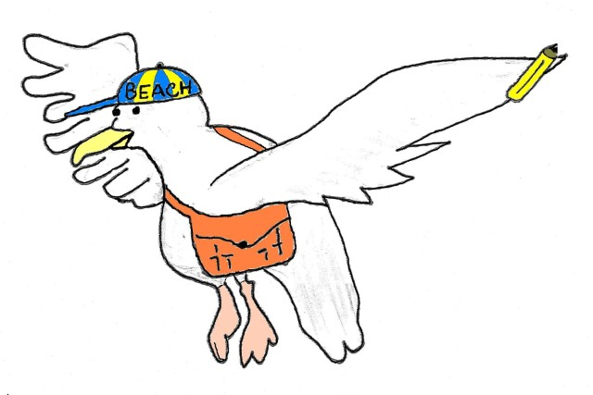*On the BUS***

***Respectful***

***\*Use a quiet voice***

***\*Speak nicely to others***

***\*Keep hands, feet, and objects to yourself***

***\*Share seat***

***\*Help others***

**SAL says to be…**



***Ready and Safe***

***\*Keep all body parts and objects inside the bus***

***\*Sit correctly***

***\*Remain seated until the bus stops***

***\*Keep your belongings on your lap or on the floor in front of you***

***\*Keep the aisle clear***

**Responsible**

***\*Listen for your bus and be on time***

***\*Listen to the bus driver***

***\*Accept consequences without or complaining***

***\*Take belongings with you***