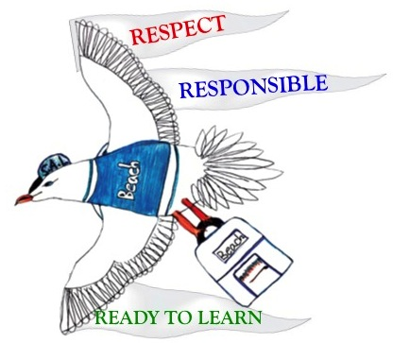
SAL says…
“Every Day We Will…”
- Greet Everyone Everyday
- Use Ask & Answer in all lessons
- Answer in complete sentences
- Use Get Fit & Get Smart options
- Everyday is a D.E.A.R. day
- Solve a Problem today
- Work Hard. Be Nice.
- Say Thank You! Make it a Habit.

