The PBIS Corner
First Quarter 2016-2017
As in previous year, Beach Elementary School is once again implementing a Positive Behavior Intervention and Support system (PBIS) designed to help students grow academically, socially, and emotionally.
During the first quarter, Beach focused on the implementation of a school-wide set of rules and procedures based on the County’s PBIS model. Our goal was to increase positive behavior and interactions by consistently and continuously enforcing our school’s expectations. To help in our efforts, students received Beach Bravos when observed being Respectful, Responsible, and Ready to learn. Our recent data shows that our efforts are paying off. For the first quarter, BES students earned a total of 6,565 Bravos for displaying one of the 3 R’s. Of the 6,000+ Bravos earned, 4,610 were traded for coupons. We would like to congratulate First Grade for being our “Top Bravo Distributors”. Second grade came in a close second. Thank you BES staff for helping keep our behavior incident reports down and our school spirit up. Way to go Beach!
For the second quarter, we will focus on being Respectful. Respect means showing consideration for others, self, other’s things, and property. Here are some ways to show respect: be polite, take turns, be patient, share, agree to disagree in a peaceful manner, and treat others the way you want to be treated. Please share with us special ways your class shows respect throughout the building for the second quarter. We would love to post some of the things you are doing in your class on our next Newsletter.
“I’ll have a “Sit with a Friend” coupon please!”
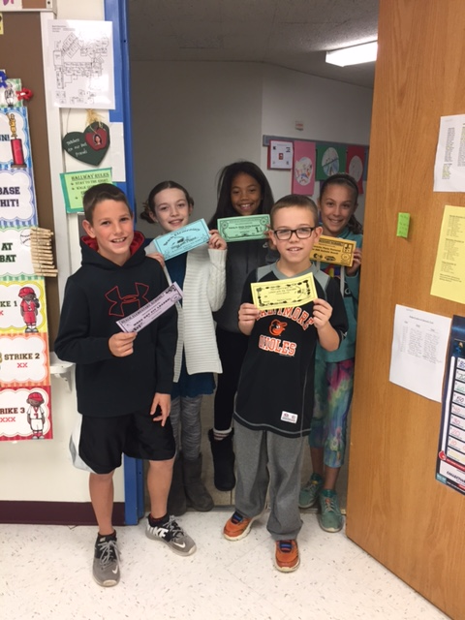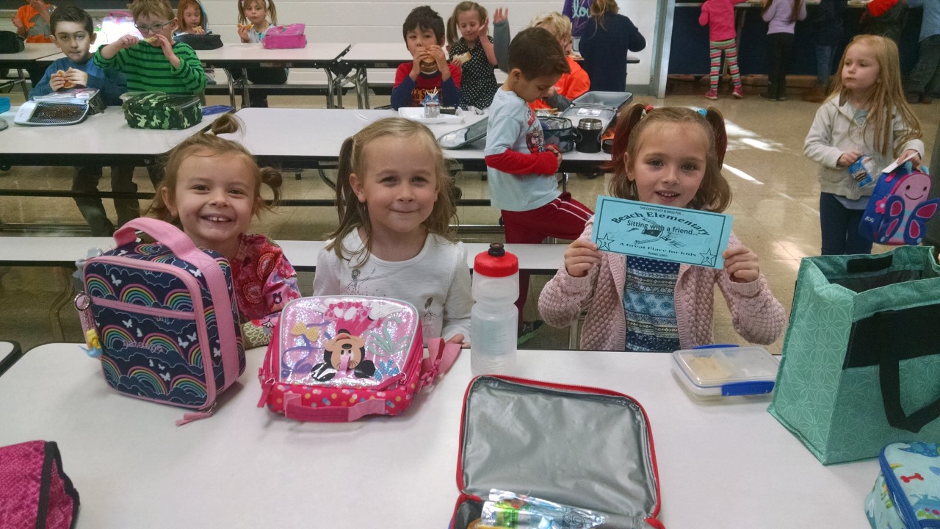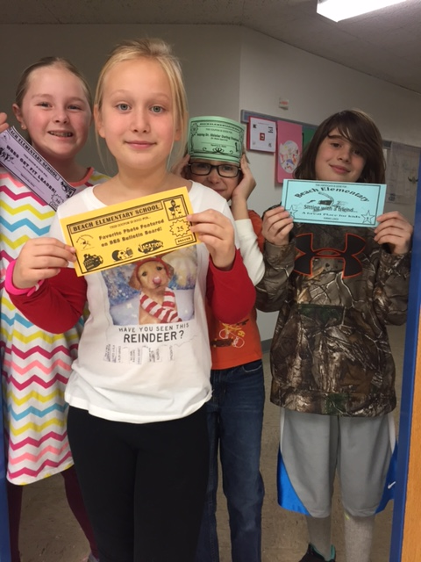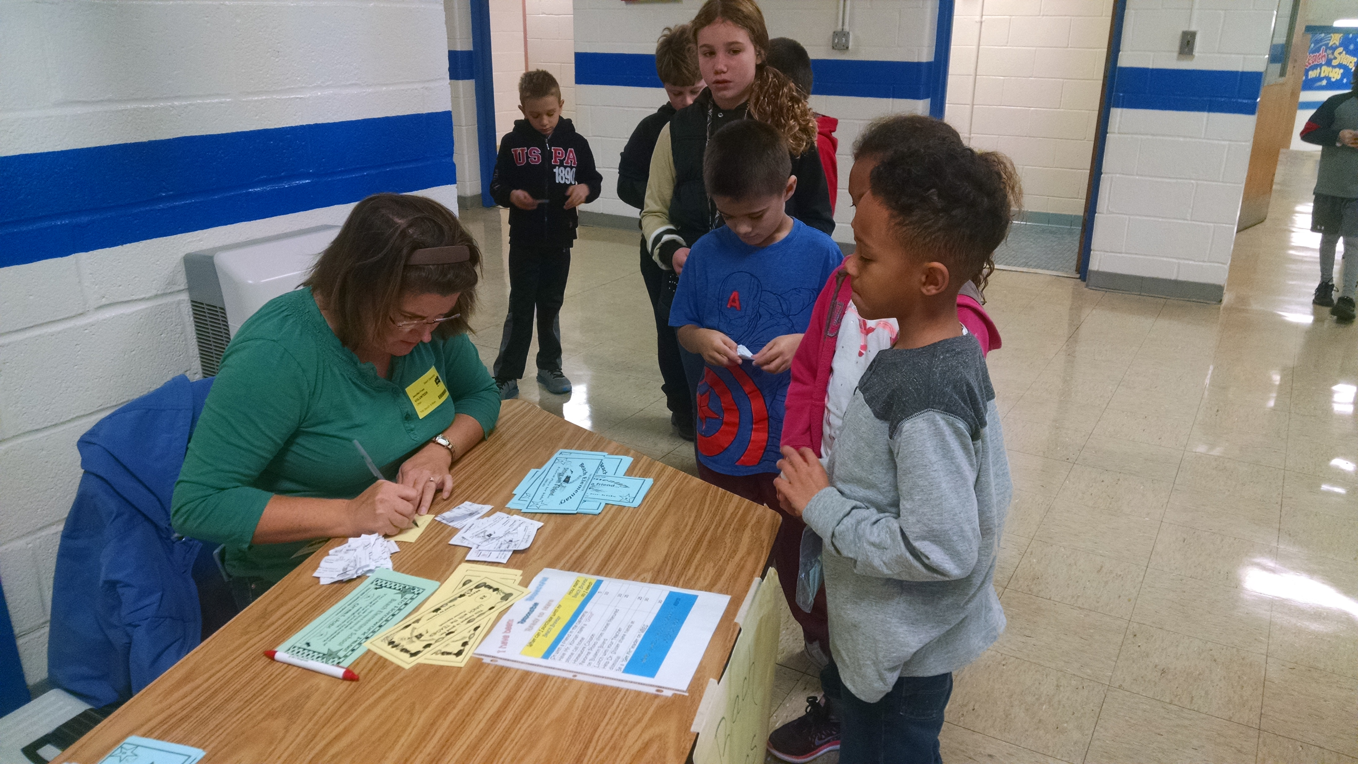

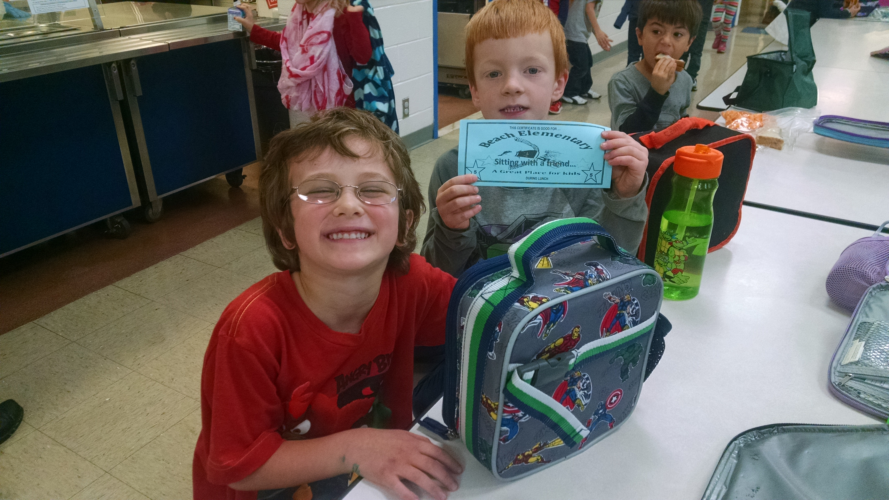

Thank you Mrs. Frum for helping out with the Bravos exchange every Thursday

